body = RigidBody_Cylinder(1, 4, 4, 8);
alpha = 1000; % positive large constant for CSM
ext = @(t) external_torque(t);
rotation_quaternion_ODE = @(t,s) rotation_quaternion_ODE_params (t,s, body, alpha, ext);
%interval = 0:0.0001:20;
tf = 20;
interval = [0,tf];
sinit = [1;0;0;0; 0;0;0;0];
[time, s] = ode45(rotation_quaternion_ODE, interval, sinit);
%making_video (body, time, s, 0.1);
making_tiled_video (body, time, s, 0.1);
function dots = rotation_quaternion_ODE_params (t,s, body, alpha, ext)
q = s(1:4); dotq = s(5:8);
ddotq = body.calculate_ddotq (q, dotq, alpha, ext(t));
dots = [dotq;ddotq];
end
function tau = external_torque(t)
if t <= 5
tau = [12.00; 0.00; 0.00];
elseif t <= 10
tau = [ 0.00; -12.00; 0.00];
else
tau = [0;0;0];
end
end
function making_video (body, time, s, videostep)
figure('position', [0, 0, 1200, 1200]);
set(0,'defaultAxesFontSize',12);
set(0,'defaultTextFontSize',12);
clf('reset');
fr = 1;
clear M;
ts = time(1);
tf = time(end);
for t=ts:videostep:tf
fprintf("time %f\n", t);
index = nearest_index(time, t);
q = s(index, 1:4);
clf;
body.draw(zeros(3,1), q);
xlim([-10,10]); ylim([-10,10]); zlim([-10,10]);
xlabel('x'); ylabel('y'); zlabel('z');
pbaspect([1 1 1]); grid on; view([-75, 30]);
drawnow;
M(fr) = getframe(gcf);
fr = fr + 1;
end
M(fr) = getframe(gcf);
v = VideoWriter('rotation_quaternion', 'MPEG-4');
open(v);
writeVideo(v, M);
close(v);
end
function making_tiled_video (body, time, s, videostep)
figure('position', [0, 0, 1600, 1600]);
set(0,'defaultAxesFontSize',12);
set(0,'defaultTextFontSize',12);
clf('reset');
fr = 1;
clear M;
ts = time(1);
tf = time(end);
for t=ts:videostep:tf
fprintf("time %f\n", t);
index = nearest_index(time, t);
q = s(index, 1:4);
clf;
tiledlayout(2,2);
%
nexttile;
body.draw(zeros(3,1), q);
xlim([-10,10]); ylim([-10,10]); zlim([-10,10]);
xlabel('x'); ylabel('y'); zlabel('z');
pbaspect([1 1 1]); grid on; view([-75, 30]);
%
nexttile;
body.draw(zeros(3,1), q);
xlim([-10,10]); ylim([-10,10]); zlim([-10,10]);
xlabel('x'); ylabel('y'); zlabel('z');
pbaspect([1 1 1]); grid on; view([0, 0]); % x-z
%
nexttile;
body.draw(zeros(3,1), q);
xlim([-10,10]); ylim([-10,10]); zlim([-10,10]);
xlabel('x'); ylabel('y'); zlabel('z');
pbaspect([1 1 1]); grid on; view([-90, 0]); % y-z
%
nexttile;
body.draw(zeros(3,1), q);
xlim([-10,10]); ylim([-10,10]); zlim([-10,10]);
xlabel('x'); ylabel('y'); zlabel('z');
pbaspect([1 1 1]); grid on; view([0, 90]); % x-y
drawnow;
M(fr) = getframe(gcf);
fr = fr + 1;
end
M(fr) = getframe(gcf);
v = VideoWriter('rotation_quaternion_tiled', 'MPEG-4');
open(v);
writeVideo(v, M);
close(v);
end

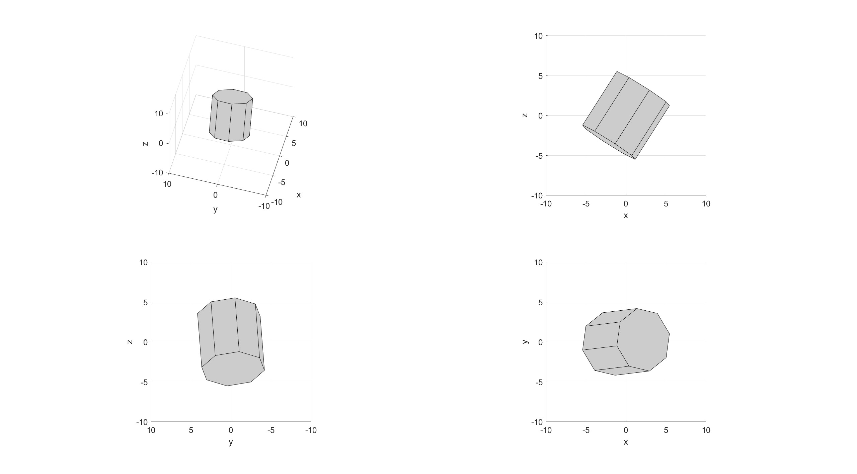
Published with MATLAB® R2022b

